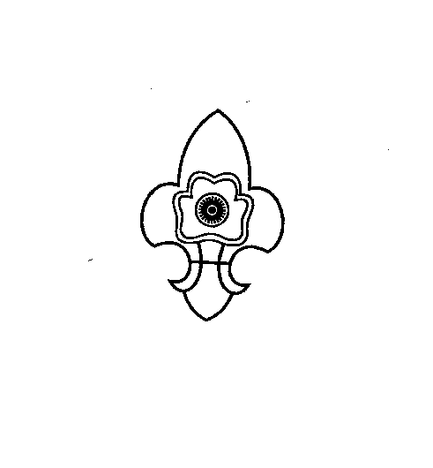
+
THE MEGHALAYA BHARAT SCOUTS & GUIDES

“Empowering the Youth, Powering the Nation”
STATE HEADQUARTERS::: PINEMOUNT-RIDGE
SHILLONG - 1.
Phone No & Fax No: (0364) 2226197
www.megscoutguide.nic.in
Email: mbsg_meghalaya@yahoo.co.in & meghalayascoutsandguides@gmail.com

No: A-14/2021/ Date: 29th January, 2021

To
All the District Secretaries,
Meghalaya Bharat Scouts and Guides,
Meghalaya.
Subject: Celebration of Founder’s Day and World Thinking Day 2021.

Sir/Madam,
Greetings! From the Fraternity of the Meghalaya Bharat Scouts and Guides.
I take the privilege to express our thanks and appreciation for all the support and active participation of all the districts in various activities during the year 2020 and especially during the Covid-19 Pandemic.
The Celebration of the “Founder’s Day and World Thinking Day” is celebrated all over the World on the 22nd of February of the year, being the Joint Birthday of the Founder and his Wife and the theme for this year is “Stand Together For Peace”.
The Founder’s Day and Thinking Day celebration 2021 will therefore be celebrated virtually by a Workshop through Zoom platform on 31st January, 7th February, 14th February and 21st February from 10.30 a.m. to 12.30 p.m. Kindly register and choose the date according to your convenience. Link for registration for the workshop is provided below
https://forms.gle/az6hpgprx6veXfWs5
I am hereby also forwarding the circular from the National Headquarters for further information and for downloading the activity pack for the World Thinking Day celebration.
In this regard I request all the members to kindly register themselves and participate actively in the workshop.
Let us celebrate the World Thinking Day 2021 with full zeal and enthusiasm.
Thanking you
Yours Sincerely

(Mrs. A. Swer)
State Secretary
MBSG, Shillong

